Campus Event System — Design & Implementation Report

1) Approach

Goals
- Produce a concise, practical design doc and implementation notes for the Campus Event System in the repo.
- Extract real schema, routes, scripts, and reporting SQL from the code I uploaded.

Assumptions & Decisions
- Use the included project defaults where possible (the repo supports sqlite3 by default via knexfile.js).
- Prototype will run on SQLite (file ./database.db) for quick local setup unless you prefer MySQL/Postgres.
- UUID strings are used as primary keys in the project (seen in migrations).
- Admin access is token-based in middleware (admin123456 used for testing in README/start script).
- Frontend talks to a REST API under /api/* (server is Express.js in src/).

AI Brainstorming (LLM) — Conversation Log (summary)
- Prompt used: “List important data entities and endpoints for a campus event system and good report queries.”
Result (summary): Identified entities: colleges, students, events, registrations, attendance, feedback. Suggested endpoints for events, registrations, attendance, admin actions and reports.
- Prompt used: “Suggest edge cases for event registration and attendance systems.”
Result (summary): Duplicate registration prevention, race conditions for capacity, cancelled events, time-zone issues, partial/missing feedback, GDPR/email uniqueness.
Note: You can save a raw chat transcript by exporting this conversation from the LLM you used (ChatGPT UI) and attach screenshots or JSON. I used the LLM to brainstorm and then followed the repository implementation — any deviations are noted below.

Where I followed vs deviated from AI suggestions
- Followed: Data model & endpoints suggested by LLM matched and aligned with code in src/routes/*.
- Deviated: The repo uses string UUIDs and a centralized dataset (not strictly separated multi-tenant databases). For the scale assumption I recommend a single dataset with tenant (college_id) column and appropriate indexes.

2) Design Document

Data to Track
- Event creation: title, description, type, college_id, capacity, start_time, end_time, venue, status, created_by, created_at
- Student registration: student_id, event_id, registration_status, registered_at, contact info
- Attendance: registration_id, present (boolean), checked_in_at
- Feedback: registration_id, rating (1–5), comment, submitted_at

Database Schema (sketch)
The repository contains a migrations/001_schema.sql file. Key tables (columns abbreviated):
- colleges (id PK, name, created_at)
- students (id PK, college_id FK, roll_no, name, email, phone, created_at)
- events (id PK, college_id FK, title, description, type, status, capacity, start_time, end_time, venue, created_at)
- registrations (id PK, event_id FK, student_id FK, status, registered_at, email, phone)
- attendance (id PK, registration_id FK, checked_in_at, present)
- feedback (id PK, registration_id FK, rating, comment, submitted_at)
(See the migration file for exact column names and indexes.)

ER Diagram
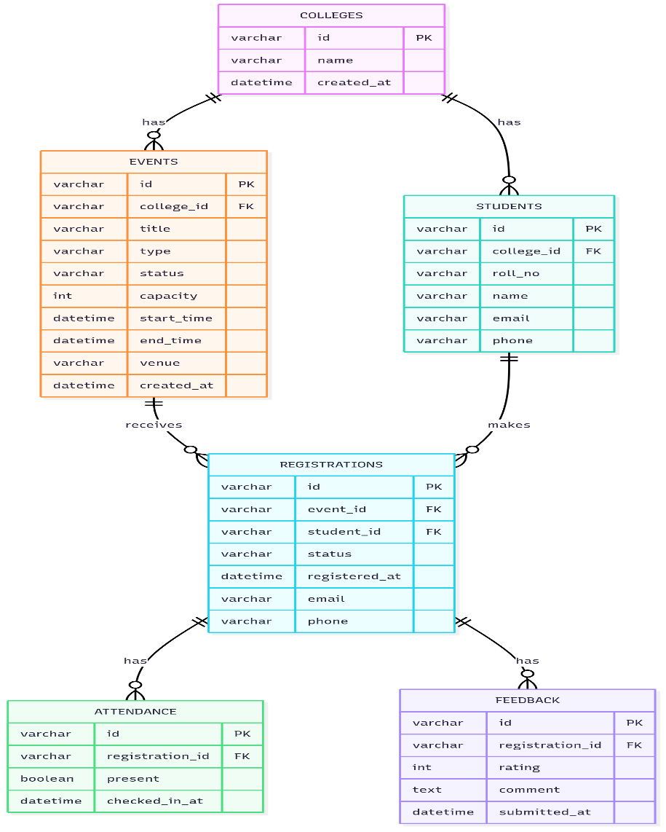

API Design (extracted & consolidated)
Base API root in the project is /api (routes are mounted in src/app.js). Below are the main endpoints (method, path, brief body/params):
Public / Student - GET /api/events — list events (filters: college_id, type, from, to, q) - GET /api/events/:id — event details (includes registration & attendance aggregates) - POST /api/events/:eventId/register — register for event - body: { name, email, phone, roll_no, college_id } (validated) - returns registration id - POST /api/registrations/:registrationId/checkin — self-checkin (mark attendance) — public endpoint in this repo - POST /api/registrations/:registrationId/feedback — submit rating + comment - GET /api/colleges — list colleges - GET /api/registrations/search?email=... — find registrations by email - GET /api/registrations/:id/details — registration + event details - GET /api/registrations/:id/feedback-status — has user submitted feedback?
Admin (require x-admin-token header validated by middleware) - POST /api/admin/events — create event (auto-create college if missing) - PUT /api/admin/events/:id — update event - DELETE /api/admin/events/:id — cancel event (soft delete / status change) - GET /api/admin/events — list events for admin - GET /api/admin/events/:eventId/registrations — list registrations for attendance - POST /api/admin/registrations/:registrationId/attendance — mark present/absent
Reporting - GET /api/reports/popularity — events sorted by registration count - GET /api/reports/attendance — aggregate attendance (optionally ?event_id=X) - GET /api/reports/feedback — aggregate feedback (optionally ?event_id=X) - GET /api/reports/student/:studentId/participation — per-student participation - GET /api/reports/top-active — most active students (ranked)
The repo also contains docs/Postman_collection.json with example API calls.

Workflows (sequence - text)
Registration workflow 1. Student browses /api/events and selects an event. 2. Client POST /api/events/:eventId/register with student info. 3. Server creates or links a student record, inserts registration (status registered). 4. Student receives registration id and can later checkin or view details.
Attendance workflow 1. Admin fetches registrations for an event via /api/admin/events/:eventId/registrations. 2. Admin marks attendance per registration using POST /api/admin/registrations/:registrationId/attendance (present/absent). 3. Or students self-checkin via /api/registrations/:registrationId/checkin. 4. Attendance rows are created/updated and counts are available in /api/events/:id.
Feedback workflow 1. After the event, student POSTs /api/registrations/:registrationId/feedback with rating and comment. 2. System prevents duplicate feedback by checking existing row for that registration. 3. Aggregated ratings are available in /api/reports/feedback.

Assumptions & Edge Cases
- Duplicate registration: prevented by checks in registration handler (repo enforces unique registration per event per student/email).
- Capacity race: project computes availability but does not include transactional locking — for scale, use DB-level transactions/unique constraints or optimistic locking.
- Missing feedback: handled by nullable feedback and an endpoint to check feedback-status.
- Cancelled events: events have status field and queries filter canceled events.
- Email uniqueness: students.email is unique in schema — be careful when auto-creating student records by email.
- Multi-tenant: per the repo design, data is stored in a single database with college_id as tenant identifier. For scale (50 colleges×500 students), this is acceptable with proper indexing.

3) Prototype Implementation (what I inspected & how to run)

Files inspected (high level)
- src/app.js, src/server.js — Express app & server
- src/db.js — Knex connection
- src/routes/events.js, src/routes/admin.js, src/routes/reports.js — main API routes
- src/controllers/validators.js — Joi schemas & admin token middleware
- migrations/001_schema.sql — DB schema
- scripts/migrate.js — runs the SQL file using the configured DB
- frontend/ — simple vanilla JS frontend (index.html + script.js)
- docs/Postman_collection.json and docs/sample_queries.sql — example requests and SQL reports

Quick local prototype run (SQLite recommended)
- Ensure Node.js is installed (v16+).
- In the project root, create a .env file (or export env vars):
DB_CLIENT=sqlite3
DB_FILENAME=./database.db
PORT=4000
- Install dependencies:
npm install
- Create DB and run migrations:
node scripts/migrate.js
# or npm run migrate (if defined)
- Seed sample data:
node scripts/seed.js
- Start server:
npm run dev
# or npm start
- Frontend: open http://localhost:4000 (or use the Postman collection in docs/).

Minimal API scripts you can use (already present in repo)
- scripts/migrate.js executes migrations/001_schema.sql against configured DB.
- scripts/seed.js seeds sample colleges, students, events, registrations, attendance and feedback.

Endpoints to verify functionality (quick smoke tests)
- Register a student: POST /api/events/:eventId/register
- Mark attendance: POST /api/admin/registrations/:registrationId/attendance (admin token header required)
- Submit feedback: POST /api/registrations/:registrationId/feedback
- Reports: GET /api/reports/popularity, GET /api/reports/attendance, GET /api/reports/feedback

4) Reports — Output Screenshots
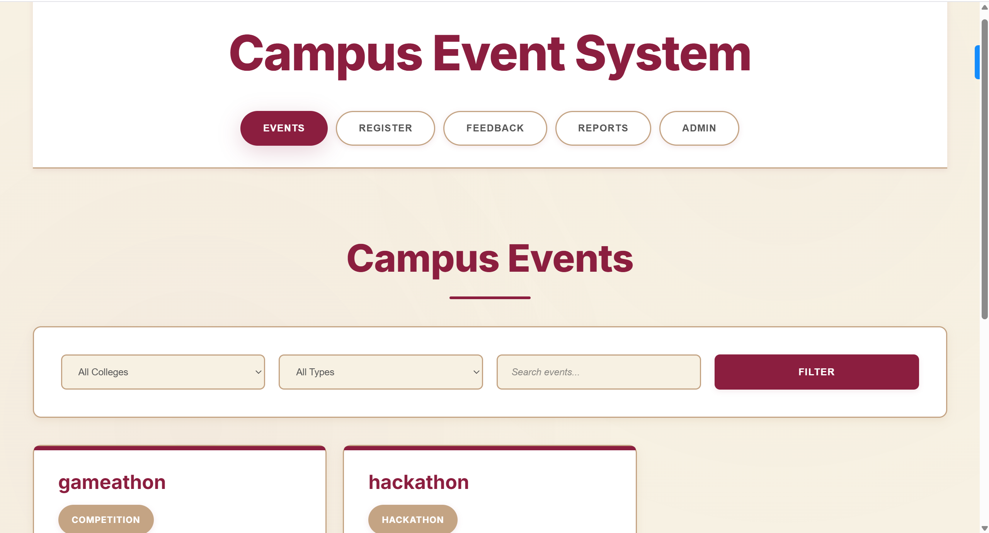
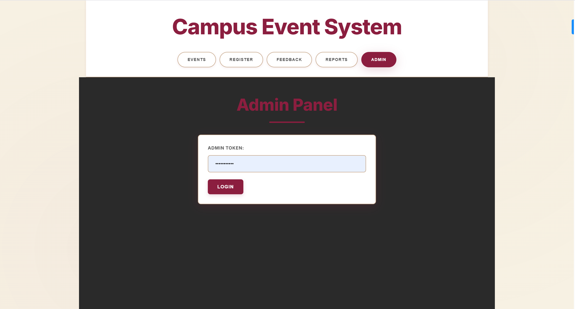

- Here the admin can access using the key “admin123456”
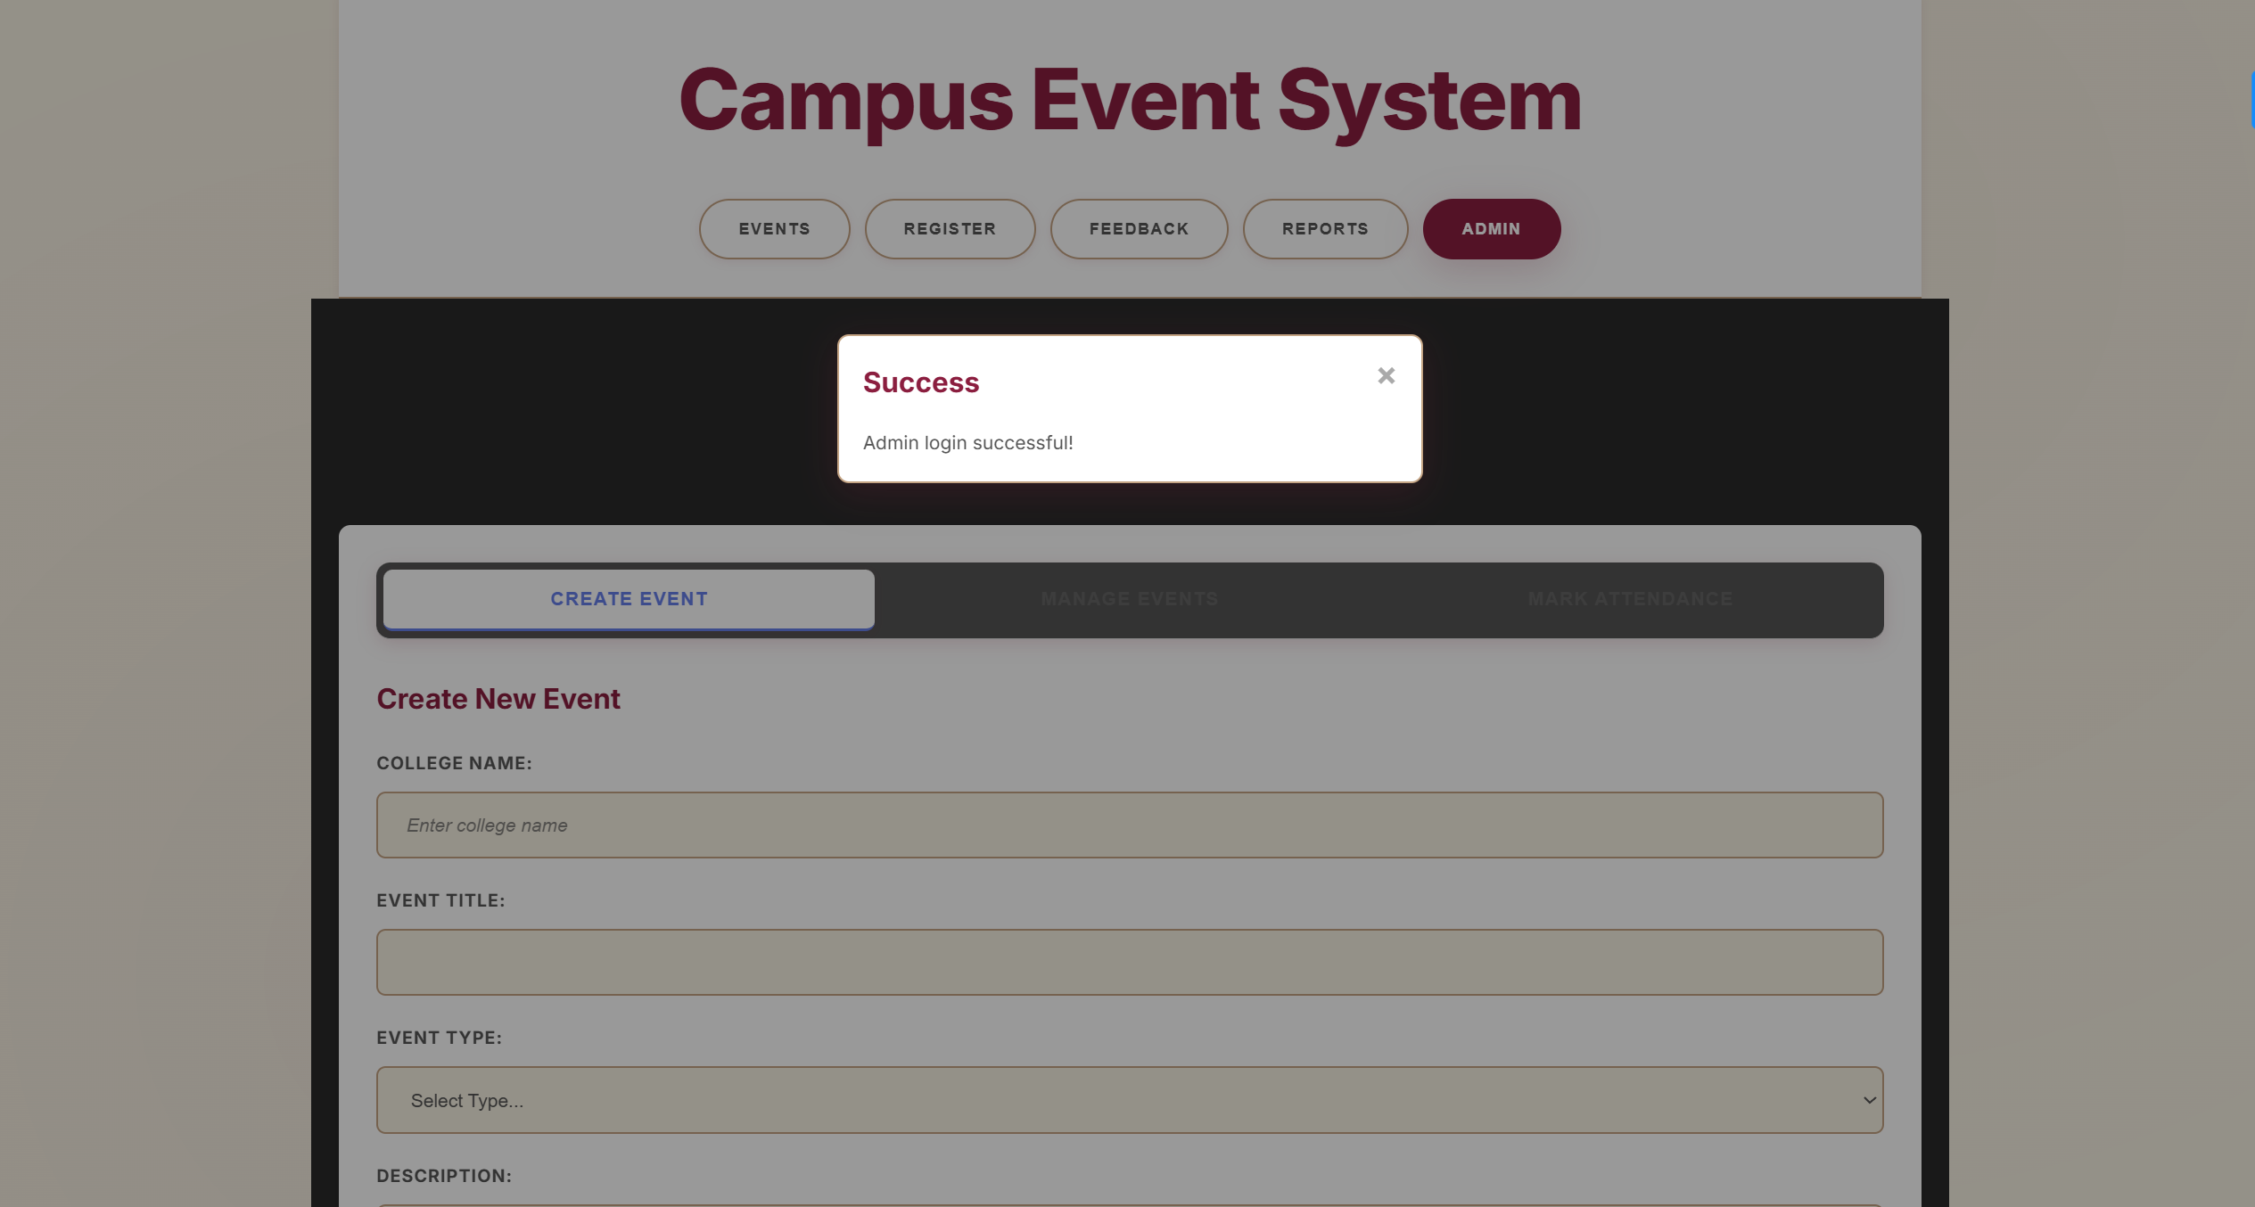

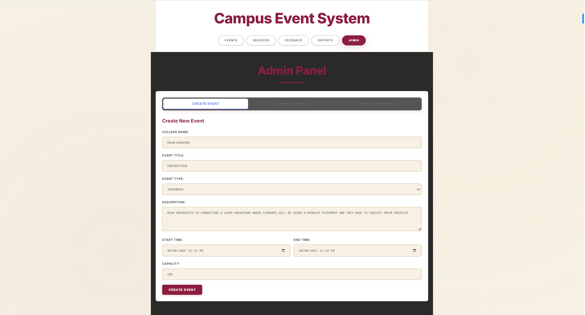
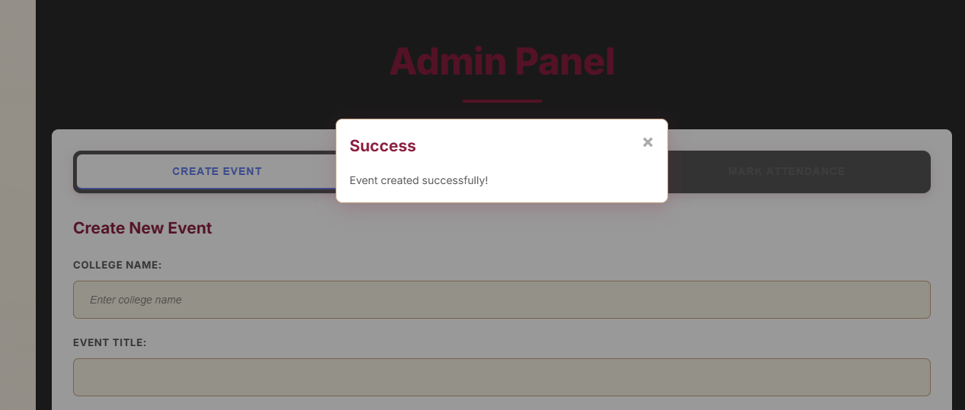
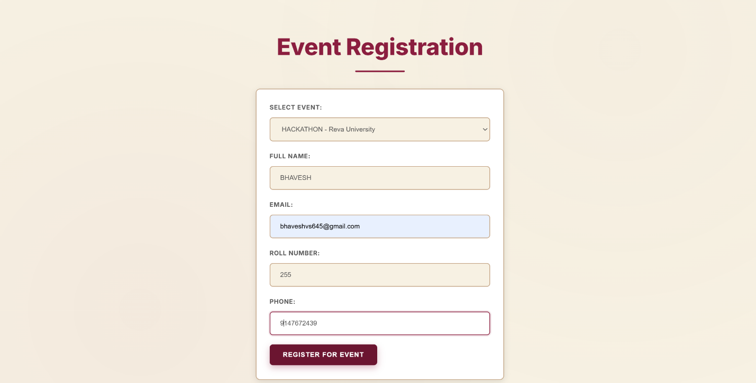
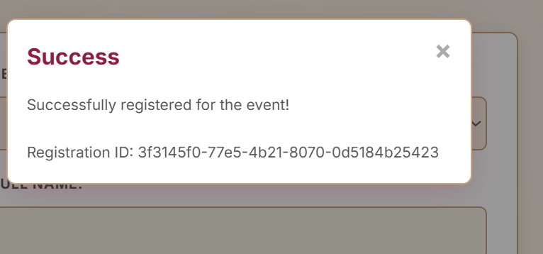
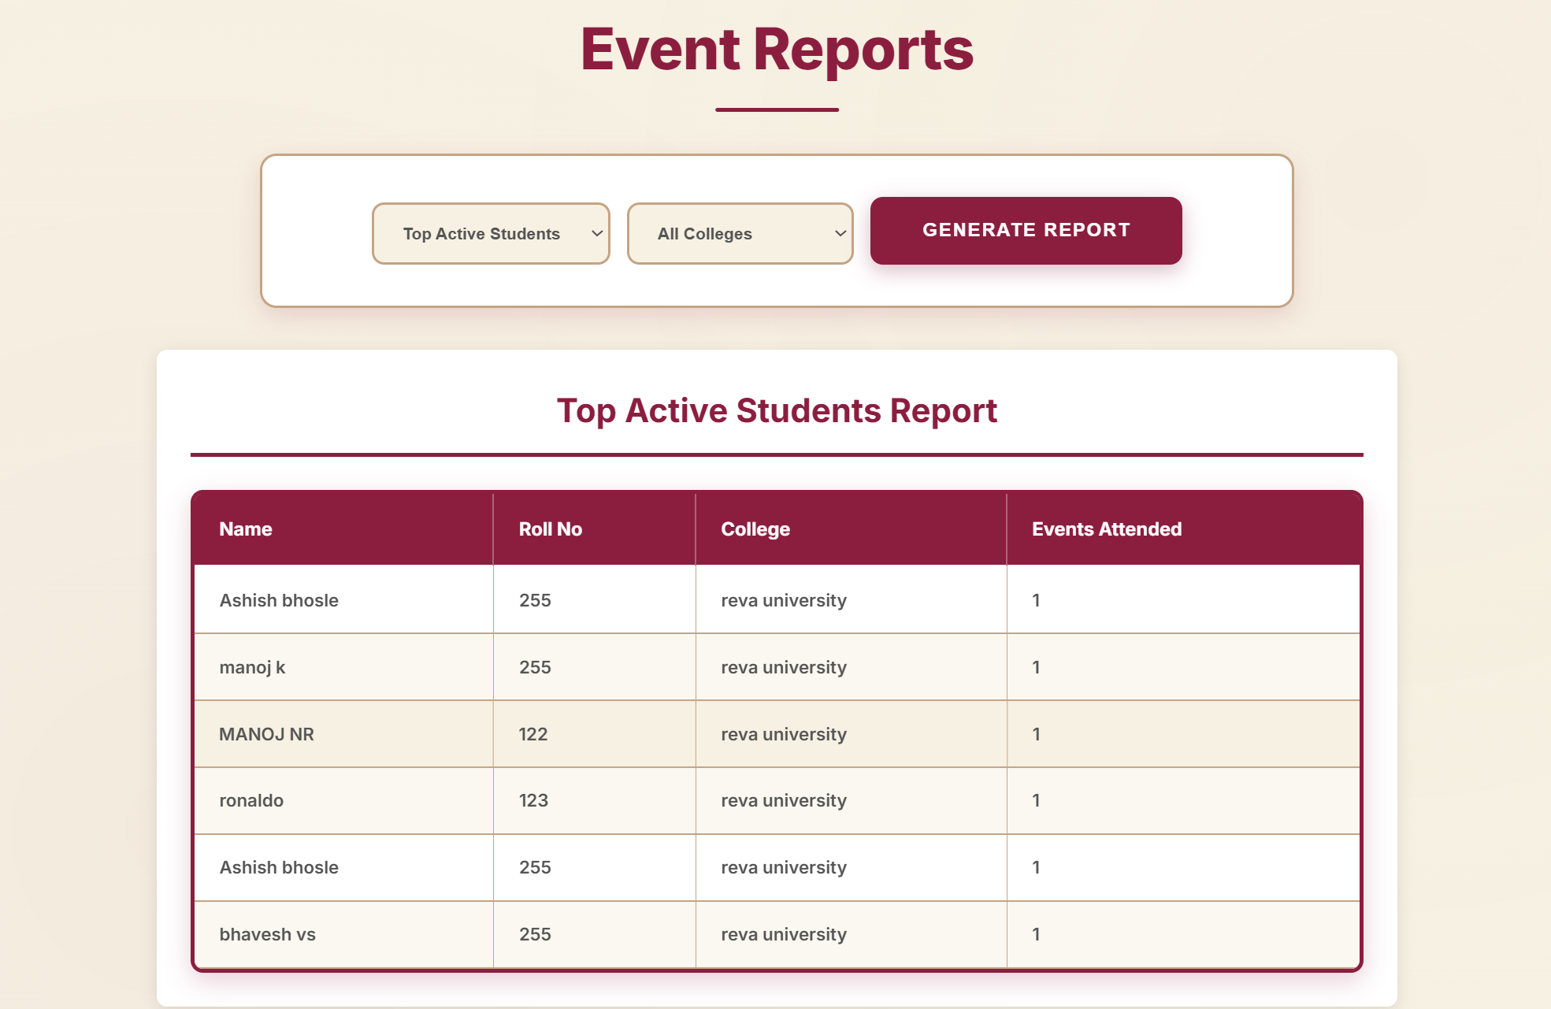
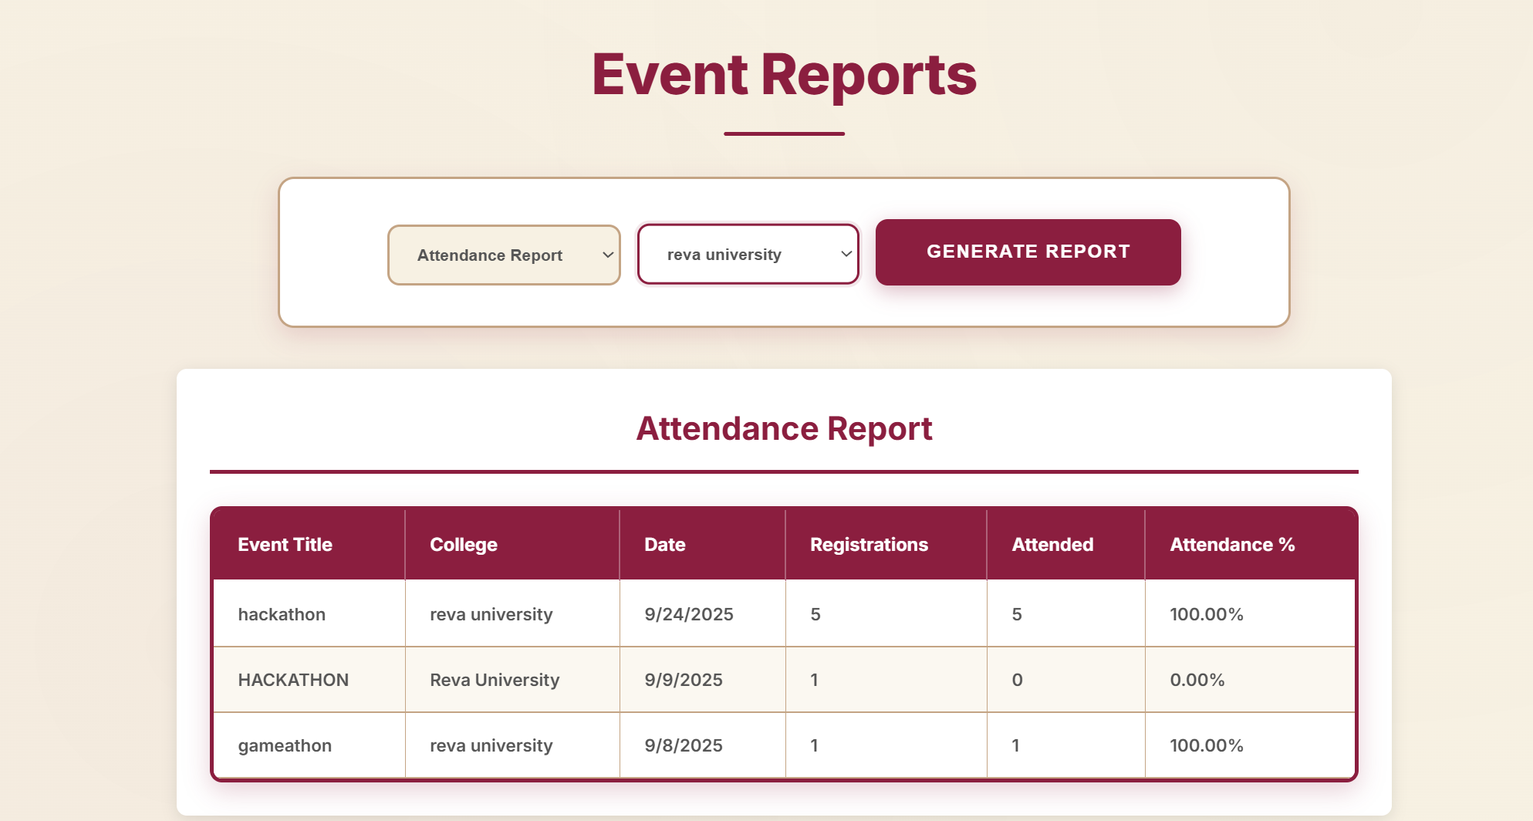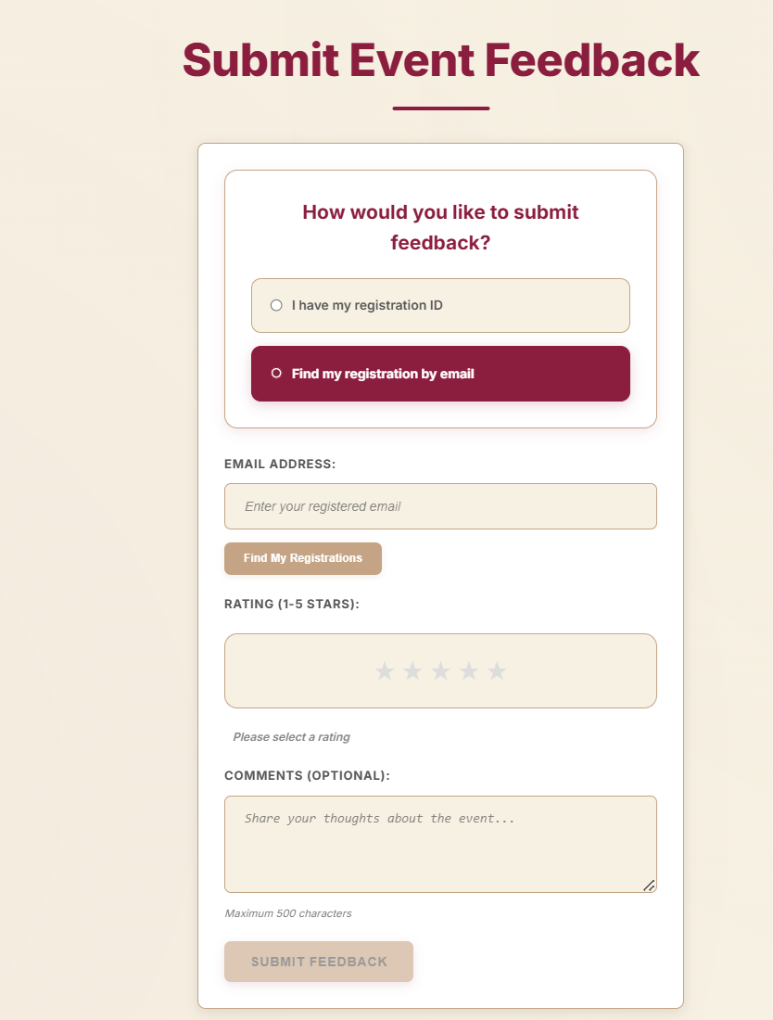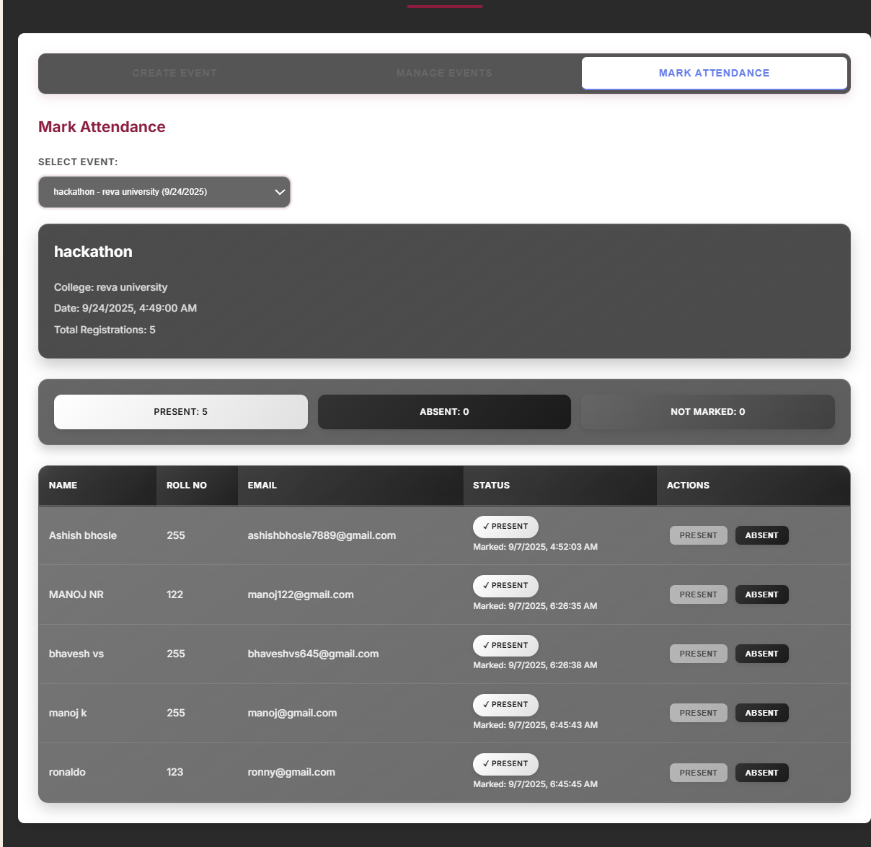

QUERY FOR TOP 3 ACTIVE PARTICIPANTS
SELECT
s.id,
s.name,
s.email,
c.name AS college,
COUNT(DISTINCT r.event_id) AS events_attended
FROM students s
JOIN colleges c ON s.college_id = c.id
JOIN registrations r ON r.student_id = s.id
JOIN attendance a ON a.registration_id = r.id
WHERE a.present = 1
GROUP BY s.id, s.name, s.email, c.name
ORDER BY events_attended DESC
LIMIT 3;

Scale Considerations (for ~50 colleges × 500 students × 20 events)
- IDs: Keep event IDs globally unique (UUIDs are fine). No need to make event IDs unique only per college.
- Single dataset vs separate DB per college: Use a single DB with college_id and proper indexes; it’s simpler for cross-college reporting. Keep college-specific permissions at application layer.
- Indexing: Use indexes on events(college_id), students(college_id), registrations(event_id, student_id), attendance(registration_id) (already present in migrations).
- Scaling read queries: Cache heavy reports (Redis) or pre-compute aggregates for very large workloads.

Next steps I can do for you (pick any)
- Generate a visual ER diagram (PNG or Mermaid diagram).
- Produce a step-by-step deployment guide to Render/Heroku/ Railway with env examples.
- Create small Postman collection runbook and example curl commands (based on docs/Postman_collection.json).
- Harden registration for capacity by converting registration creation to transactional operation with a unique DB constraint.

Quick pointers I noticed in the codebase
- knexfile.js supports both sqlite3 and mysql2 depending on DB_CLIENT.
- scripts/migrate.js executes migrations/001_schema.sql which creates the tables and indexes.
- Admin token middleware uses a simple header x-admin-token for demo/testing.
- Frontend is static and calls API endpoints (see frontend/script.js) — good for demoing a prototype.

